VISUAL STYLE GUIDE

* By Deepthi Dastari

**Table of Contents**

1) Dashboard Guidelines 2

a) What is a dashboard? 3

b) Types of dashboards 4

i. Strategic/Executive 4

ii. Functional 5

c) Layout Considerations for Dashboards 6

i. Organizing the dashboard 6

ii. Structure 8

iii. White Spaces 10

d) Evaluating your dashboards 10

2) Report Guidelines 11

a) What is a report? 11

b) Generic Guidelines for Reports 11

i. Colors 11

ii. Typography 15

iii. Choosing the right chart type 17

iv. Visualization Ideas for different chart types 19

v. Basic functionality recommendations on Reports 25

vi. Advanced functionality recommendations on Reports 26

vii. Best practices/guidelines for chart and table design 27

viii. Evaluating your reports 32

c) Report guidelines 33

i. Best Practices – Dos and Don’ts 33

3) References 35

4) APPENDIX 37

# **Dashboard Guidelines**

## **What is a dashboard?**

A dashboard (shown below) is a snapshot, presenting an overview of an organization’s metrics and KPIs. It is meant to be monitored at a glance.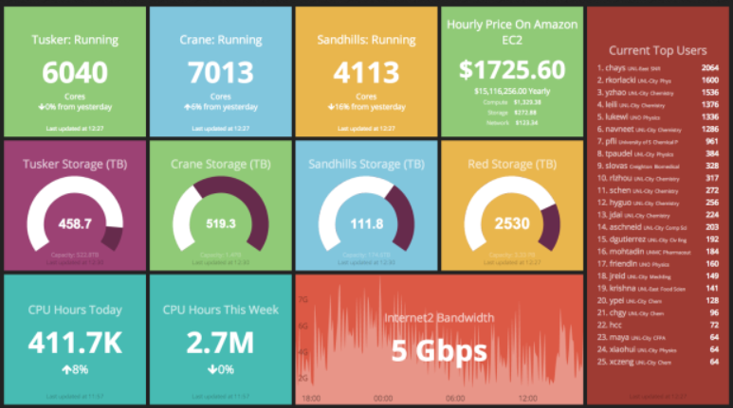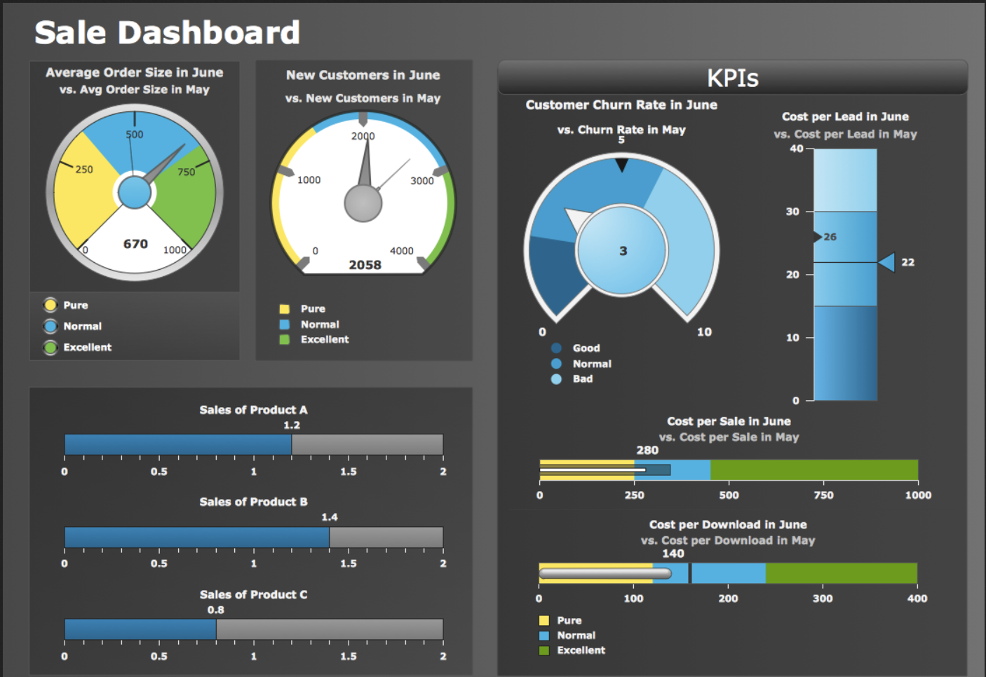

## **Types of dashboards**

* + 1. **Strategic/Executive**

Strategic dashboards will typically provide the KPI’s (Key Performance Indicators) that a company’s executive team tracks on a periodic (daily, weekly or monthly) basis. A strategic dashboard should provide the executive team with a high-level overview of the state of the business together with the opportunities the business faces.

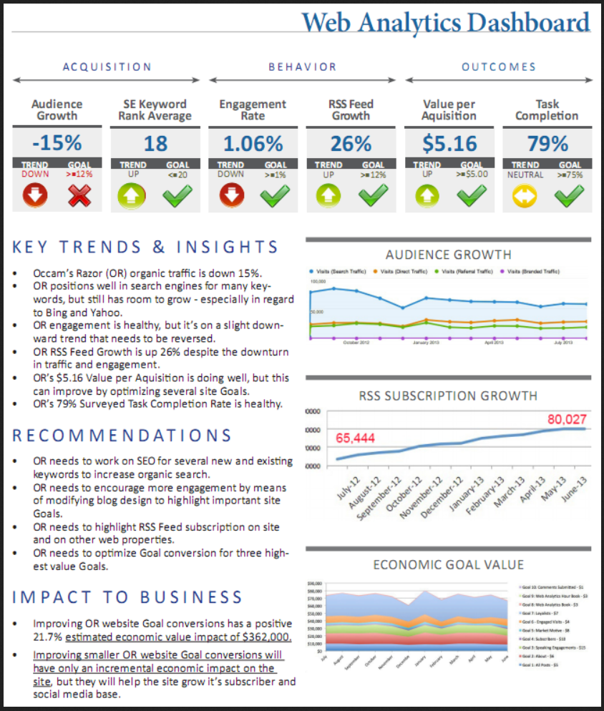

Figure 1.1: Example of an Executive/Strategic Dashboard

* + - 1. **Recommended Sections in a Strategic/Executive Dashboard:**
         1. **Insights**: Not a repetition of what the data already says, rather what caused graph one to be up or down – the reasons for the performance identified by your analysis and causal factors. Letting the data speak for itself can be a recipe for misinterpretation and confusion. So, try to build in explicit guidance about what a change in a metric means, or who to contact to address an issues that is highlighted in the dashboard.
         2. **Recommendations for Actions**: Based on your insight, mention what action needs to be taken (The *so what* based on data you have summarized and snapshotted).
         3. **Business Impact**: Mention the impact on the business if the CXO accepts your recommendation and the business takes action.
    1. **Functional**

Functional dashboards display data that facilitate the operational side of a business. Think of an operational dashboard as monitoring the nerve center of your operation. Operational dashboards often require real-time or near real-time data.

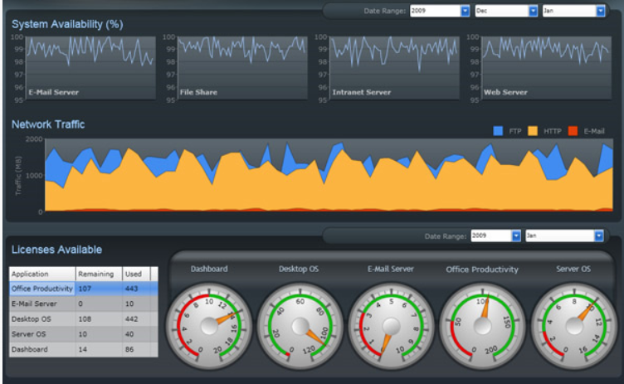

Figure 1.2: Example of a Functional Dashboard

## **Layout Considerations for Dashboards**

1. **Organizing the dashboard**

People have a bias in how they read and scan content (described in Figure 1.3)

1. Primary Optical Area – The higher left portion of the page is the user’s primary focus
2. Strong Fallow Area – The second stage of reading habit is moving to the higher right porting of the page, you can think of it as a follow up from the left portion but less important.
3. Weak Fallow Area – The lower left portion, although readable is not given much importance
4. Terminal Area – When the user reaches the lower right portion of the page, there is a break in the reading or “page scan” process. This is the perfect spot to insert call-to-action such as buttons, links, forms etc.

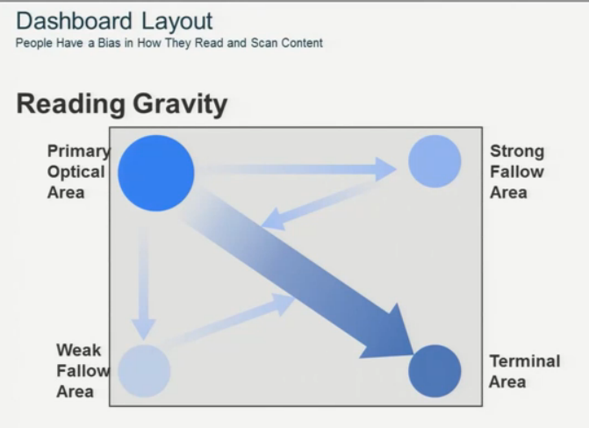

Figure 1.3: Dashboard Layout depicting how people read and scan

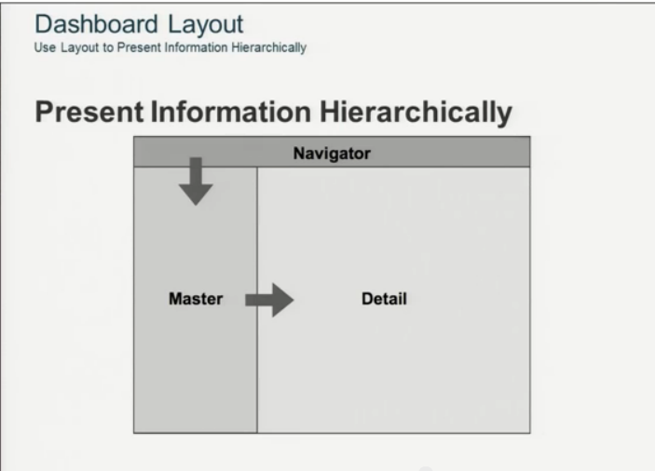

Figure 1.4: Layout for displaying information hierarchically

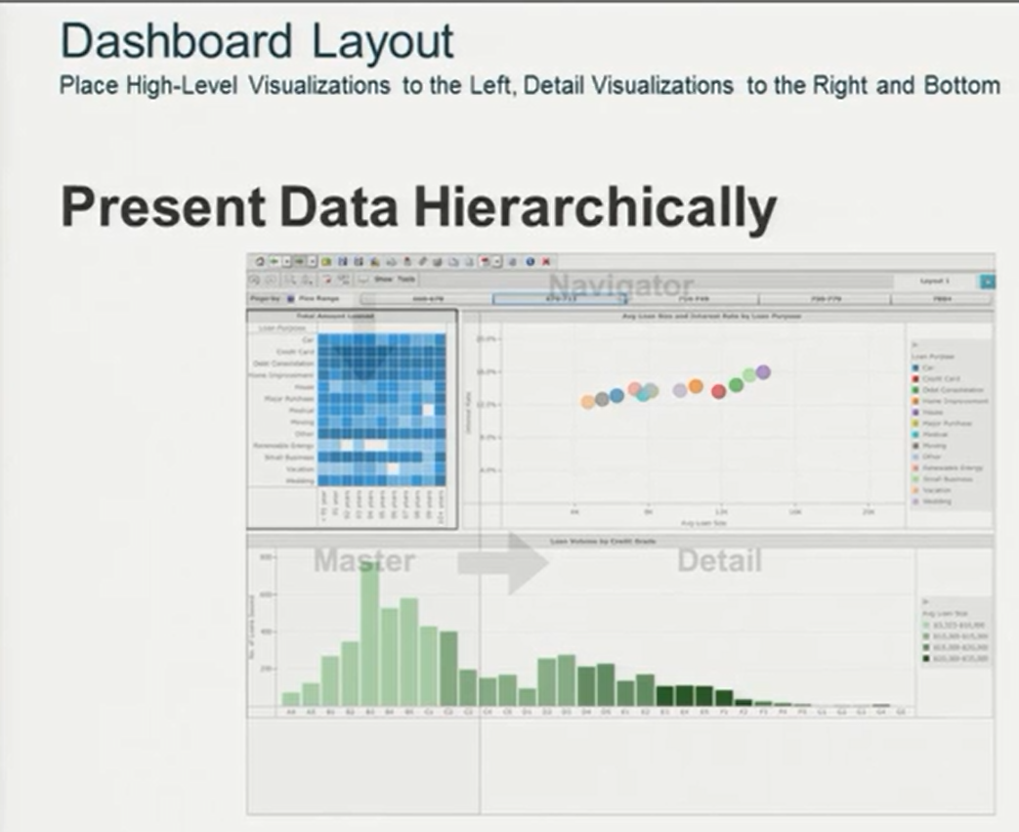

Figure 1.5: Layout for displaying high level and detailed data

1. **Structure**
2. Flow

A flow-based structure emphasizes a sequence of events or actions across time. Systems that fit this model include leads moving through a sales pipeline, stages of customers support, and operational processes.



Figure 1.6: Flow based structure for content on dashboards

1. Relationships

The structure of a dashboard can also emphasize the relationships between entities or measures. These relationships or connections may be mathematical, geographical, organizational, or functional.

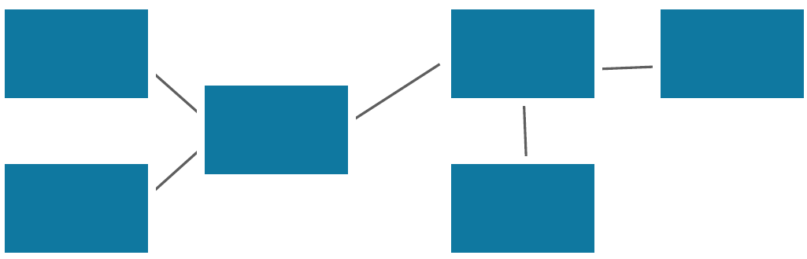

Figure 1.7: Relationship based structure for content on dashboards

1. Grouping

Group related information into categories or a hierarchy. The simple act of putting similar things together can bring some logic and accessibility to an otherwise haphazard dashboard.

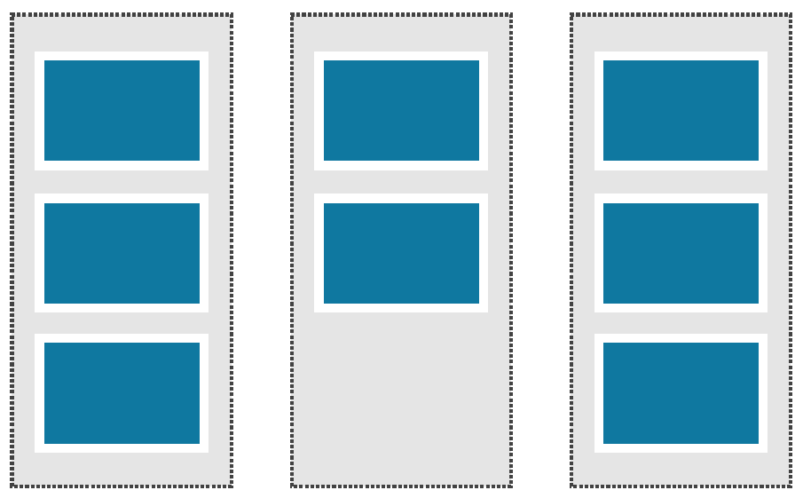

Figure 1.8: Category based structure for content on dashboards

1. **White Spaces**
   * + 1. White space in interface design is very important and too often overlooked. Maximizing dashboard real estate must also mean creating places for the eye to "rest" so that the non-white space has more impact.
       2. When we don't have sufficient spacing, everything runs together and we can't see what is most important.
       3. White space can be used to delineate sections or help users see groupings of content in a dashboard.
       4. Using white space may mean sacrificing one extra chart or metric, but it can make a huge difference in user comprehension.

## **Evaluating your dashboards**

Once you have designed your dashboard, use these questions as a checklist to make sure if all the elements of your design are working well together

1. **Is your dashboard holistic?**
   * + 1. Do all your charts fit together to tell a single story?
       2. Do all your charts flow well from one to the next? Are they in a good order?
       3. Do your most important charts appear in the top or top-left corner?
       4. Do you have scrollbars in your dashboards? If so, are they acceptable ones?
       5. Are your charts scrunched?
       6. Do all the colors on your dashboard go together without clashing?
       7. Do you use fonts consistently in all of your charts?

# **Report Guidelines**

## **What is a report?**

Reports usually will offer drill-down functionality - allowing the user to explore more of the data and get different insights.

## **Generic Guidelines for Reports**

1. **Colors**
   * + 1. Meaning in color

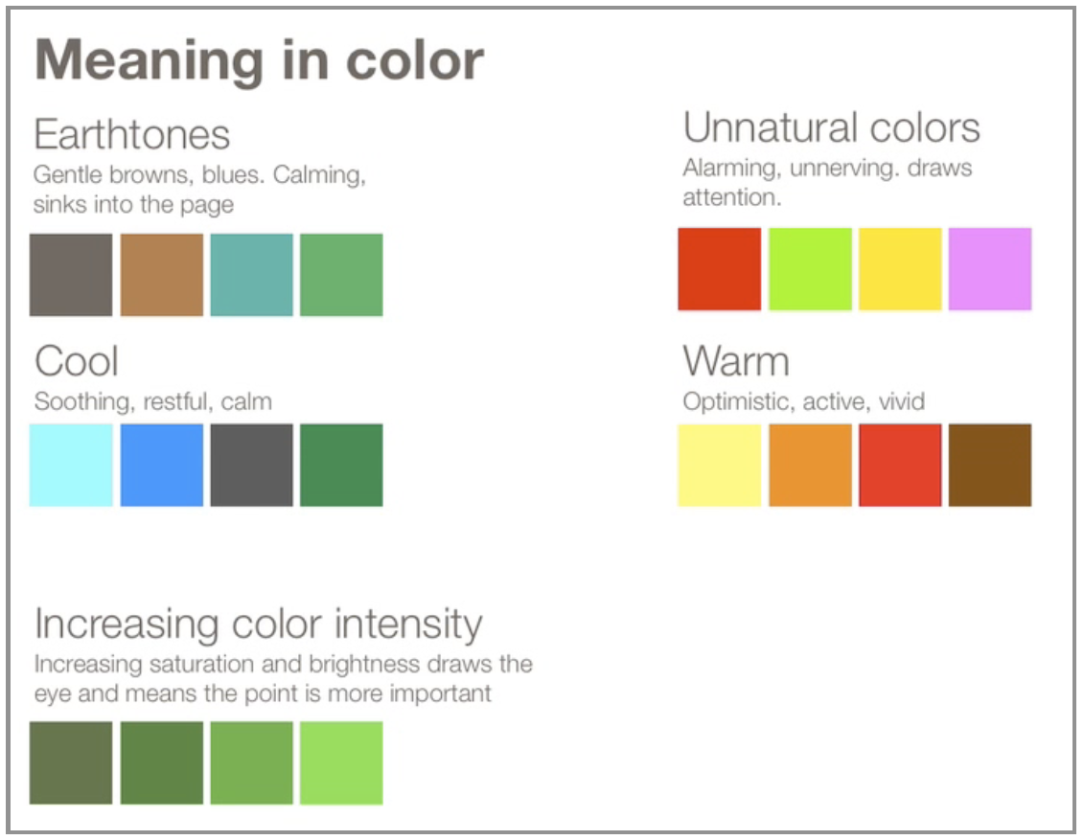

Figure 1.9: Meaning of different types of colors

* + - 1. Purpose of using colors

1. To highlight particular data

Recommendations on a bright, dark palette of the same hues, which could be used to highlight data:



1. To group items(Categorical)

When color is used to organize data into separate groups, we want those colors to look very different from one another to clearly delineate the groups. Recommendations on a collection of hues that are as distant from one another as possible along the color spectrum, but similar in intensity are:



Recommendations for a light, pale palette



1. To encode quantitative values

Sequential: When using color to encode a sequential range of quantitative values, stick with a single hue (or a small set of closely related hues) and vary intensity from pale colors for low values to increasingly darker and brighter colors for high values.



Divergent:Diverging palettes encode a range of quantitative values that are above or below some logical breakpoint in the middle.



1. For comparison

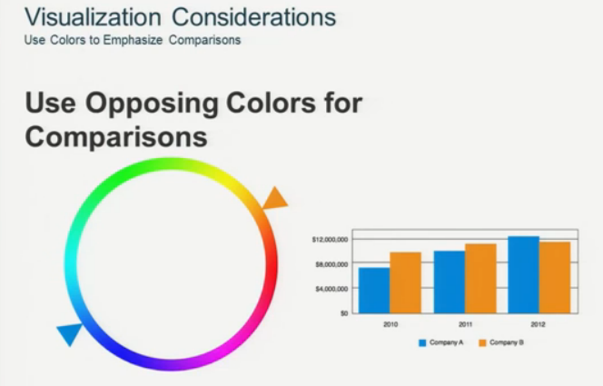

Figure 1.10: Opposing colors for comparison

* + - 1. Adding colors – best practices

1. If you want different objects of the same color in a table or graph to look the same, make sure that the background (the color that surrounds them) is consistent.

An application of this rule to graphs is to avoid gradients of color in the background or varying the background in any other way.

1. If you want objects in a table or graph to be easily seen, use a background color that contrasts sufficiently with the object.
2. Use different colors only when they correspond to difference of meaning in data.
3. Use soft, natural colors to display most information and bright and/or dark colors to highlight information that requires greater attention.
4. When objects are small or thin:

* Colors that we use to encode them must sometimes be brighter than otherwise necessary.
* Another solution is to thicken the lines or enlarge the data points.

1. Non-data components of tables and graphs(e.g. axis lines, borders, background fill colors etc.) should be displayed just visibly enough to perform their role:
   * Axis lines - Use thin gray lines of medium intensity.
   * Borders - Whether around the graph as a whole, its plot area, or a legend, when borders are needed (and usually they are not), use thin gray lines of medium intensity.
   * Background - Use white.
2. Limit the number of colors in a single view

 

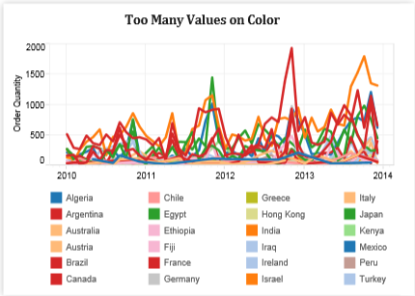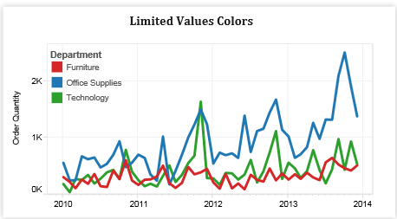

1. **Typography**

Typography includes everything from choosing a font, to picking the right point size, kerning, tracking and leading.

* + - 1. Simple Font Framework

The majority of text on the page falls into four categories:

* Body text is clean, readable content.
* Headers separate and name major sections of your work.
* Notes describe additional things the reader should be aware of. These should fade into the background unless we call attention to them.
* Emphasis text is what we want our reader to pay particular attention to.

The following table describes an approach for deciding how to display each of these text types. The yellow highlights indicate where you need to make decisions.

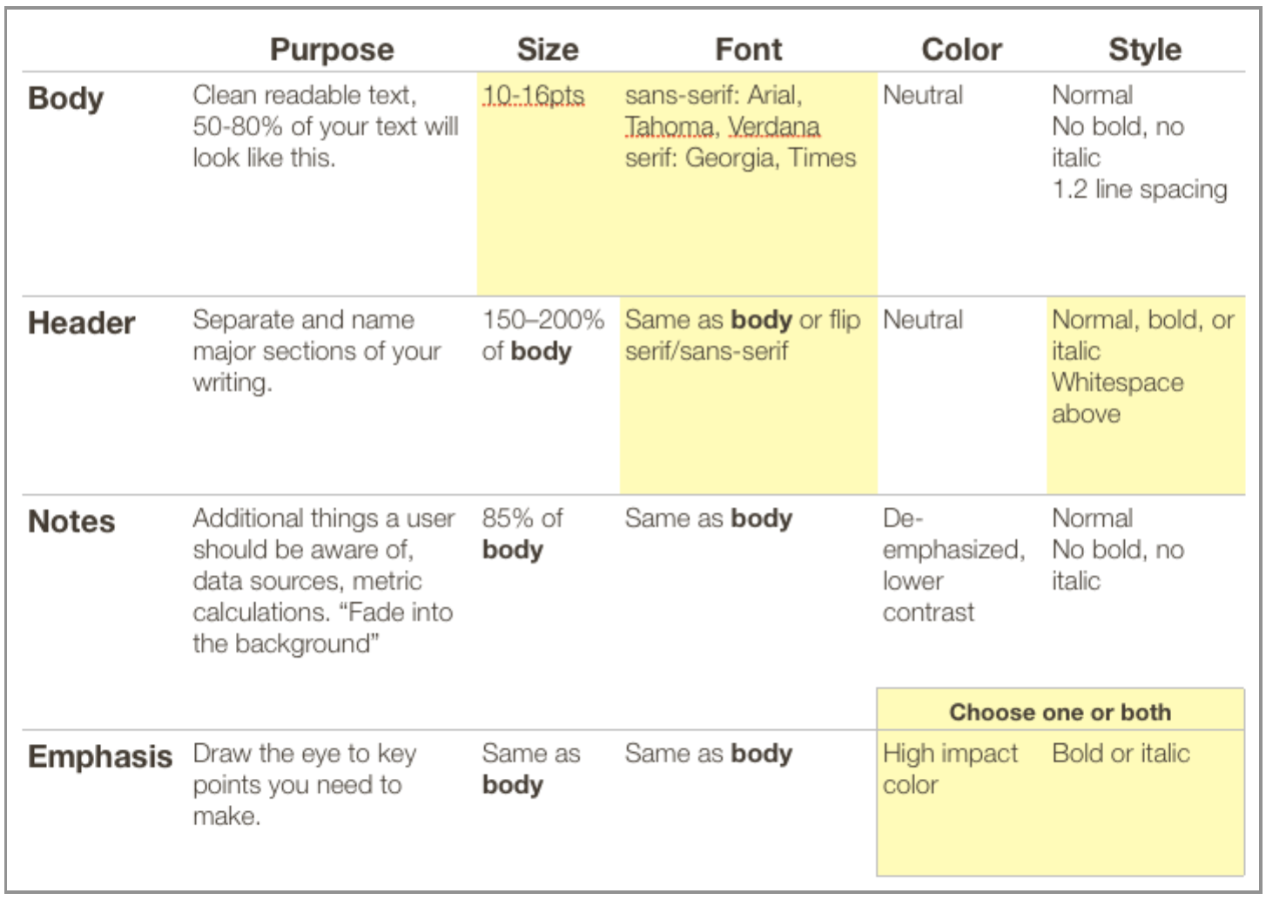

Figure 1.11: Framework for displaying different text types

You need to make three basic decisions:

1. Choose size and font of the body text.
2. Decide if the header is going to flip to serif or sans-serif—and whether it is going to have any style.
3. Decide what to do about emphasis—color or (bold or italic).

A few things don't fit neatly into one of the four text categories listed above, such as table headers and graph titles. We could use a combination of styles to handle these exceptions.

* + - 1. Font – best practices

1. All caps is less legible than regular text and generally should be avoided.
2. Italics adds a sense of emphasis and urgency.
3. Bold text, in contrast, is urgent and loud. When bold text is part of a sentence, you will tend to look at it first.
4. **Choosing the right chart type**
5. Based on type of data
   * + - 1. Types of data

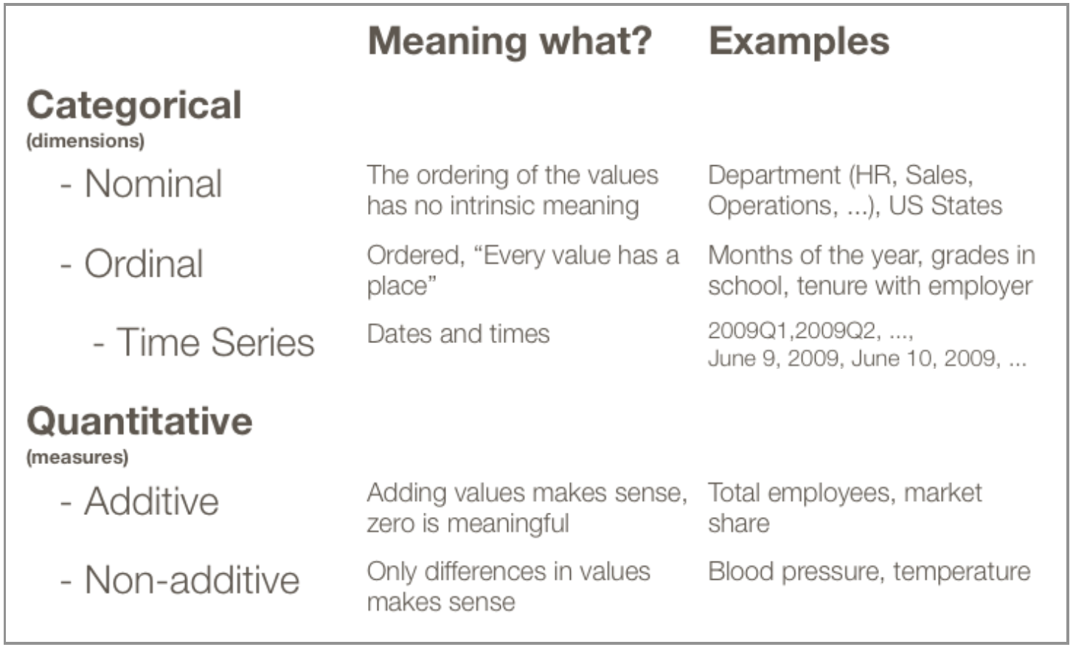

Figure 1.12: Types of data and their meaning

* + - * 1. Recommended charts:

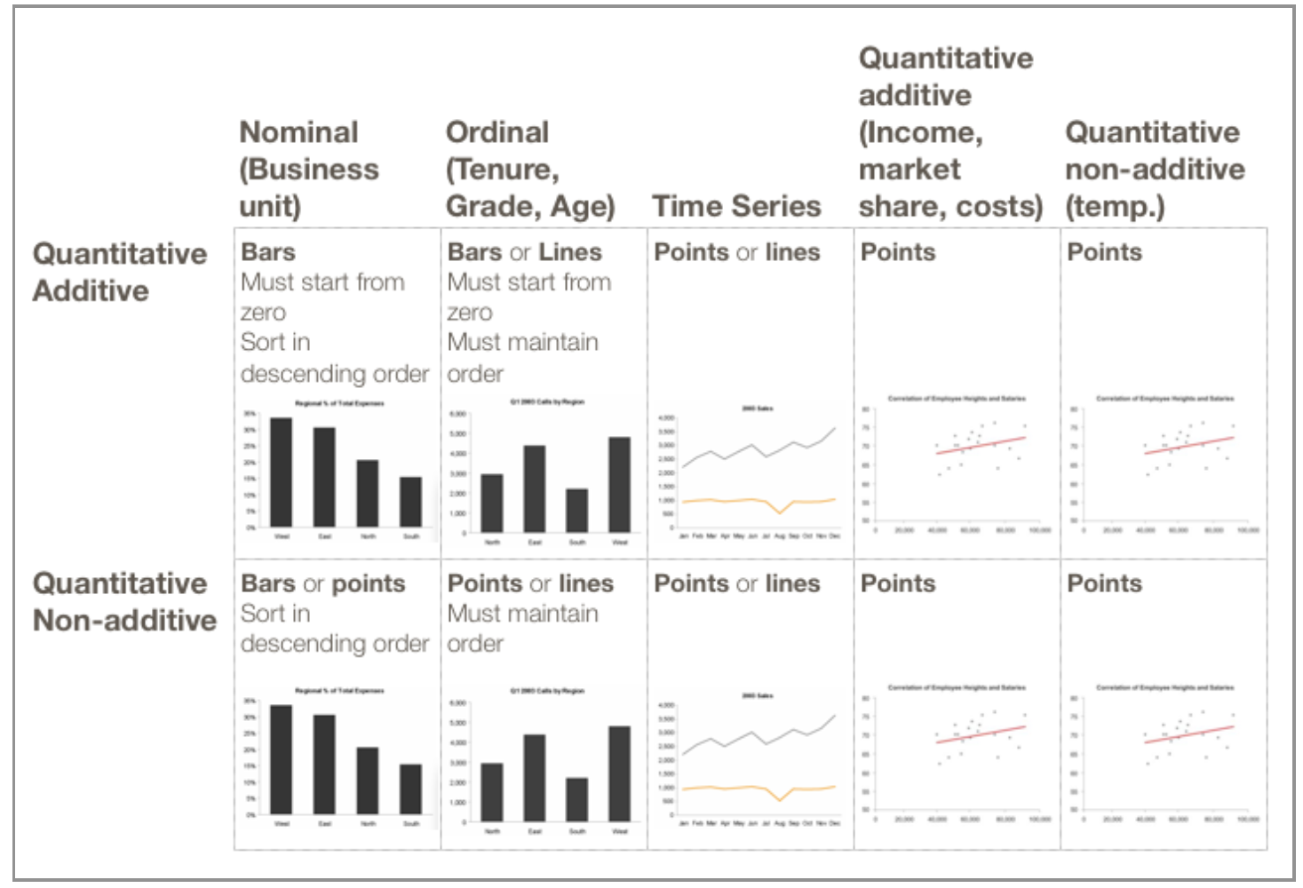

Figure 1.13: Recommended charts based on type of data

1. Based on purpose of visualization

When you're putting together a chart, you're trying to show one of four things with the data you have:

Relationship: A relationship tries to show a connection or correlation between two or more variables through the data presented, like the market cap of a given stock over time versus overall market trend.

Comparison: A comparison tries to set one set of variables apart from another, and display how those two variables interact, like the number of visitors to five competing web sites in a single month.

Composition: A composition tries to collect different types of information that make up a whole and display them together, like the search terms that those visitors used to land on your site, or how many of them came from links, search engines, or direct traffic.

Distribution**:** A distribution tries to lay out a collection of related or unrelated information simple to see how it correlates, if at all, and to understand if there's any interaction between the variables, like the number of bugs reported during each month of a beta.

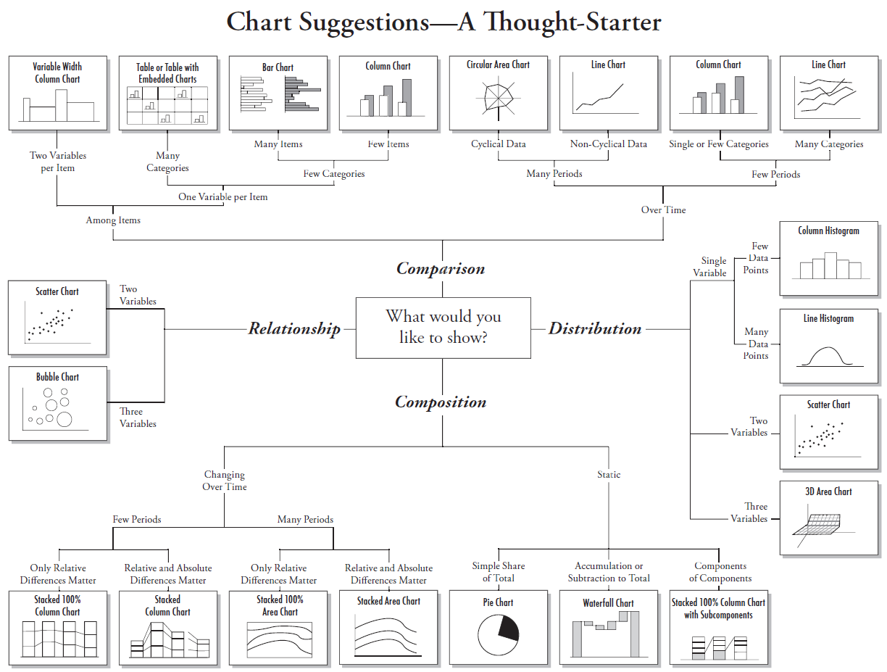

Figure 1.14: Recommended charts based on the purpose of visualization

1. **Visualization Ideas for different chart types**
2. Cards

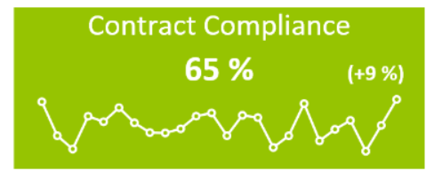

Figure 1.15: KPI Indicator

This visualization is all about visualizing Key Performance Indicators. The status is presented as a color indication, comparing the actual and target values. Deviation is presented as distance in percent of actual from target. The history (trend) is presented as a line or a bar chart. It is up to the user to decide the granularity of the data displayed. Any dimension attributes can be used, but it’s recommended to stick to the ones in your date dimension.

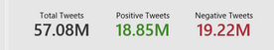

Figure 1.16: Cards color coded w.r.t sentiment

1. Gauge Charts

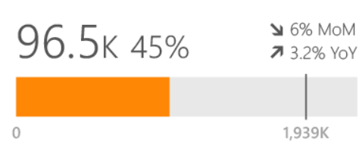

Figure 1.17: Linear Gauge

Create at-a-glance visualization to compare your progress against identified goals and warning zones. By allowing you to include multiple data points, the component provides the ability to illustrate trend details, such as monthly or year-to-date completion rates. The pointer notes targets and the colored bar shows the current progress toward those goals.

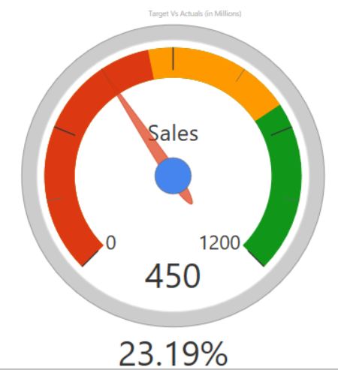

Figure 1.1.8: Dial Gauge

Description for custom ‘Dial Gauge’ visualization are as below:

1. Color indicated by red displays actual value.

2. Color indicated by yellow displays target value.

3. Pointer displays any value.

4. Null/blank/max values will be indicated by color green.

5. Default minimum value is 0.

6. Default maximum value is 100.

7. Additional label to display value. It append % sign.

8. Name of chart will be displayed on center of Dial Gauge.

1. Slicer

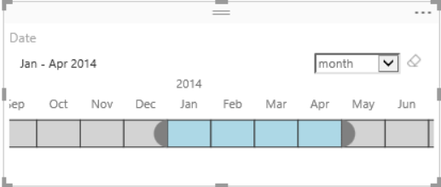 Figure 1.19: Timeline slicer

Timeline slicer is a graphical date range selector used as a filtering component in the report canvas.

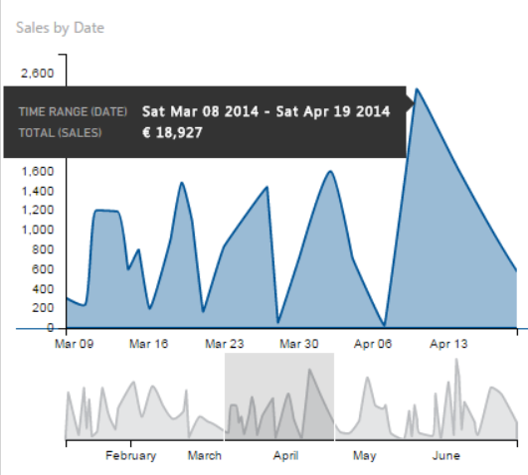

Figure 1.20: Advanced Time Slicer

The Advanced Time Slicer or "zoomed" Line Chart, will display a miniaturized preview of the data for the provided time period – the overview view. Details of the selected measure are displayed in the top chart – the details view. The time period can be adjusted in the slicer my moving the relevant time-window.

1. Donut Chart

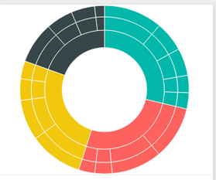

Figure 1.21: Sunburst Donut chart

Sunburst is a multilevel donut chart, used to visualize hierarchical data, depicted by concentric circles.

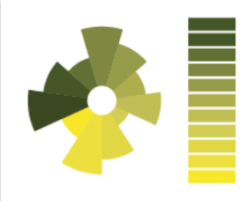

Figure 1.22: Aster Plot

An Aster plot is a twist on a standard donut chart, using a second value to drive sweep angle.

1. Area Chart

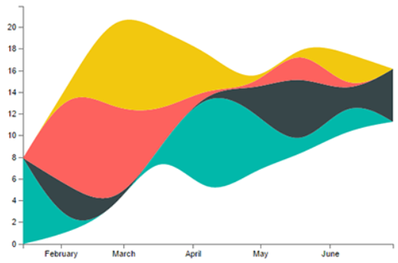

Figure 1.23: Stream Graph

A stacked area chart with smooth interpolation. Often used to display values over time.

1. Maps

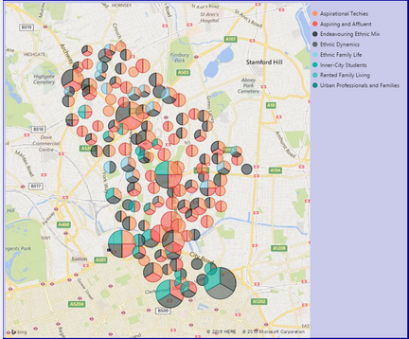

Figure 1.24: Map with different distributions

1. Stacked Bar/Column Chart

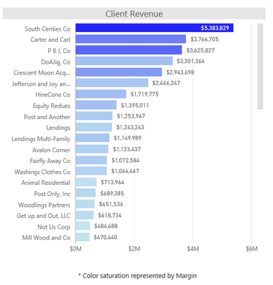

Figure 1.25: Stacked bar chart with color gradient

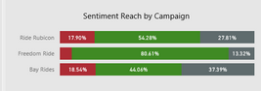

Figure 1.26: Color coded stacked Column chart

1. Line Charts

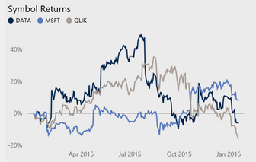

Figure 1.27: Line Chart without gridlines

1. Tables

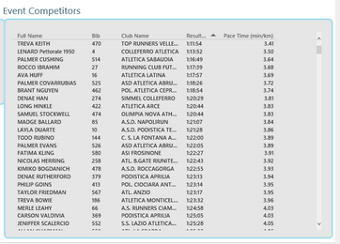

Fig 1.28: Table without gridlines

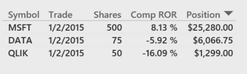

Fig 1.29: Table showing positive/negative percentages

1. **Basic functionality recommendations on Reports**
2. Drill Down: Ability to go from a summary metric or view to additional detail that provides more context and/or breakout of the information.
3. Filters: Allow users to define the scope of the data in the dashboard to reflect their needs. Filters can either be global (refining scope for the entire dashboard) or local (refining scope for a specific chart or metric or view).
4. Alerts: Highlight information based on pre-defined criteria. The alert may be activated when a metric goes outside of a particular threshold.
5. Export / print: Give users the ability to pull information out of a dashboard. Export to formats that let users do more with the data like Excel and CSV rather than PDF.
6. **Advanced functionality recommendations on Reports**
7. Text- based summary: Automatically generated textual description of the key information in the dashboard. This can be as simple as a sentence that includes a couple important data points.
8. Starring/tagging: Ability for users to identify things in the dashboard that are important to them. The virtual equivalent of circling a number with a red pen.
9. Annotation: Allow users to add commentary to specific numbers or charts. The virtual equivalent of writing notes in the margin.
10. Save / track changes: The more a user configures a dashboard to their unique needs, the more important it becomes to allow them to save what they have created.
11. Advanced visualizations: If it is useful to show more complex data in the dashboard, a variety of advanced visualizations can help make it digestible. A few visualization types to consider include geographic map, tree map, network diagram, tag cloud, scatterplots and bubble charts. But be careful, using complex visualizations incorrectly can leave your audience feeling lost and confused.
12. **Best practices/guidelines for chart and table design**
13. Reduce chart-junk: By removing elements that are decorative or ornamental. One example could be 3-D chart effects.



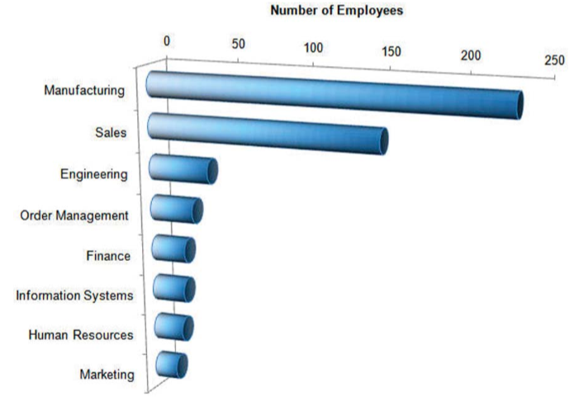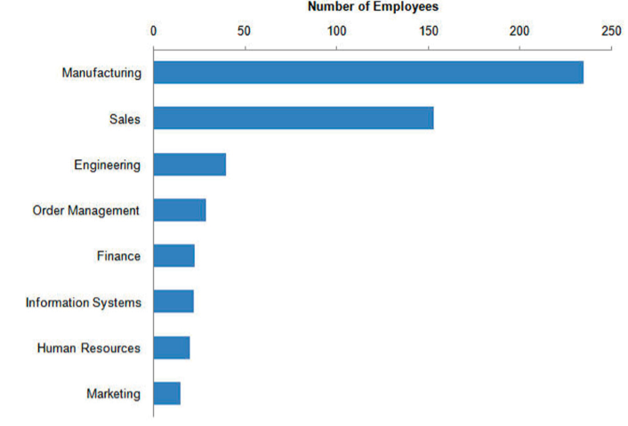

1. Readable labels: Whenever possible, avoid rotated labels; they are hard for people to read and distract from focusing on the numbers.

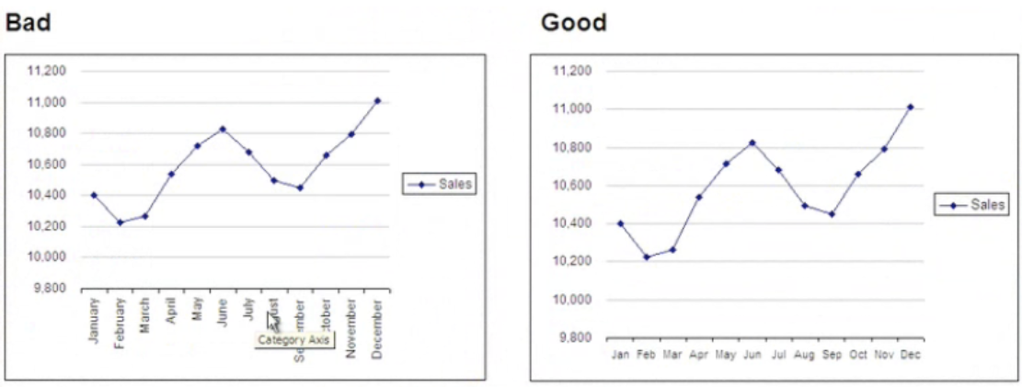

1. Avoid repetition: It’s not necessary to have both a legend and a title for single series graphs. Likewise, the title of a chart may suffice to explain what the reader is looking at.

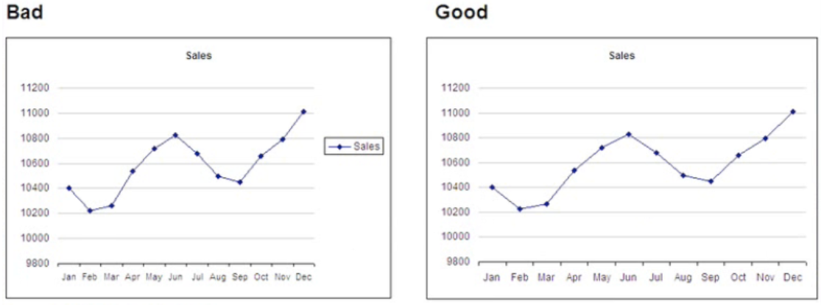

A useful alternative to a legend is to label the individual data series directly.

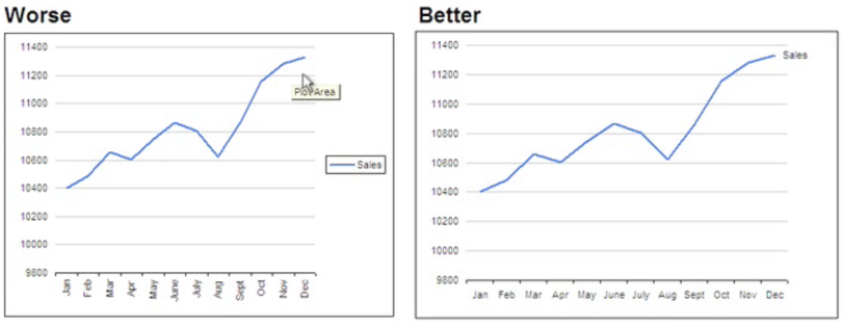

1. Avoid smoothing and 3D: Avoid adding a smoothing feature to your line; it gives the impression of data points that are not there.

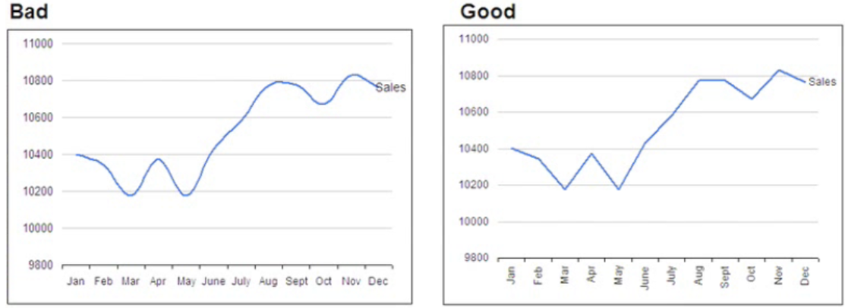

1. Use gradients carefully: Use flat colors or a bare minimum gradient and ensure that the end point is visible. When the gradient fades towards the endpoint, it reduces the ability to clearly see the length of the bar.

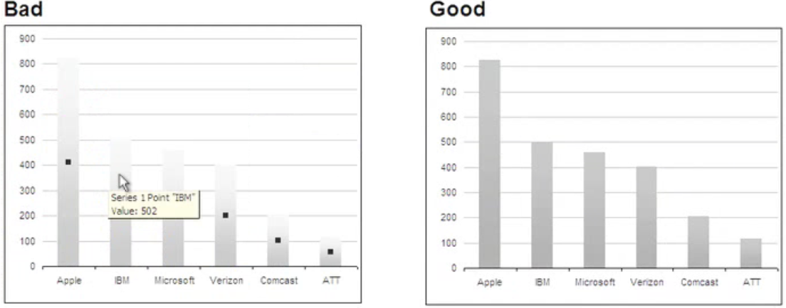

1. Sort for comprehension: Add structure and clarity to the chart by sorting by a metric of interest.

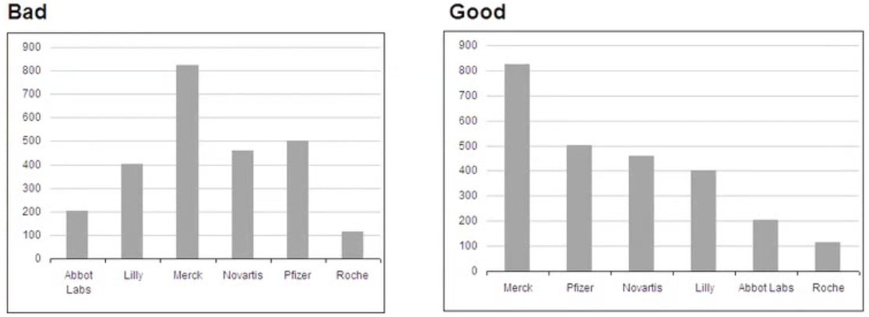

1. Use color variants: If you are displaying multicolumn or stacked charts, use variants on a hue or grey to show different data series.

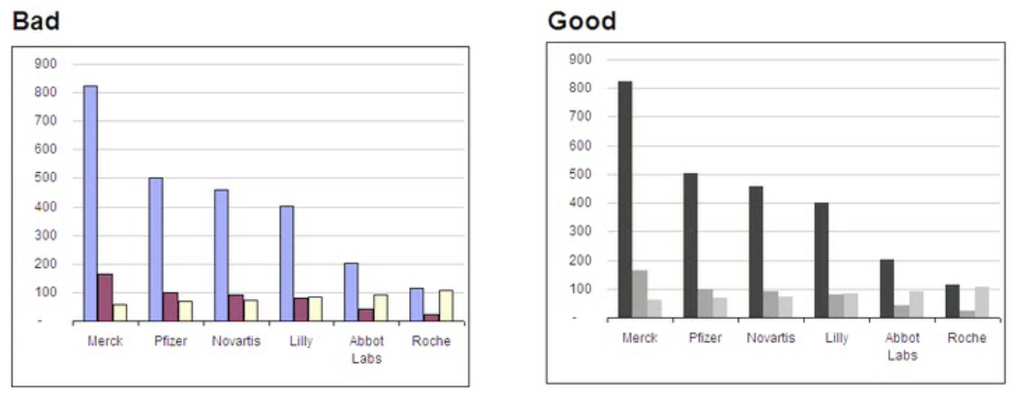

Also, don’t vary the colors by point. This creates a lot of unnecessary visual noise and makes similar colors seem related. Bright colors are get more perceived emphasis.

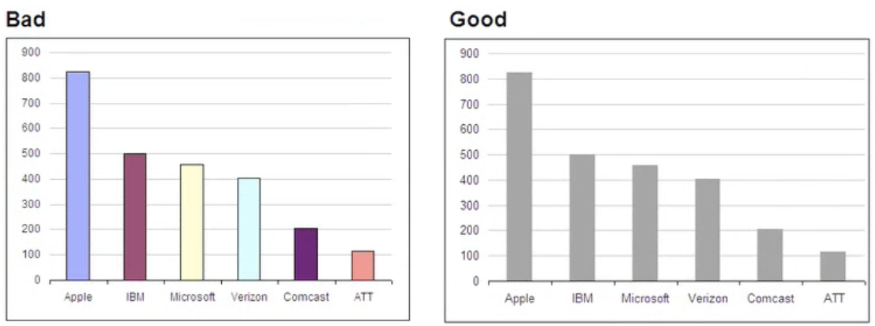

1. Orient your views for legibility: If u find yourself with a view that has long labels that only fit vertically, try rotating the view.

 

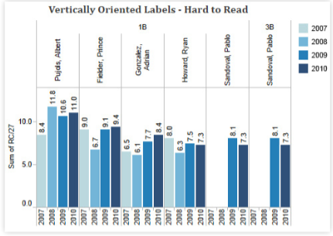 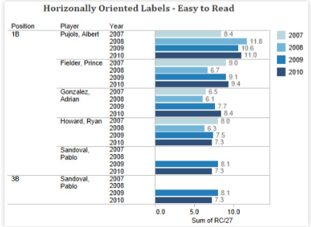

1. Avoid overloading your views: Overloading a view is one of the most common mistakes people make in data visualization. Instead of stacking many measures and dimensions into one condensed view, break them down to small multiples.

 

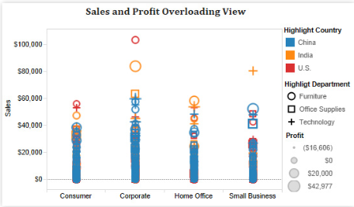 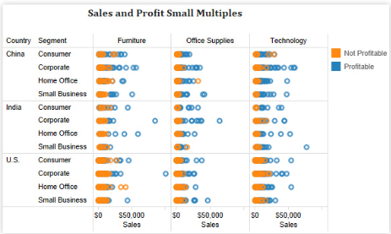

1. Tables
   * + - 1. Remove gridlines.
         2. Use lines or whitespaces to separate areas that are conceptually different.
         3. Display the smallest amount of numbers that you can to support the needs of the table.
         4. Use consistent column and row spacing to create horizontal and vertical rhythm.

 

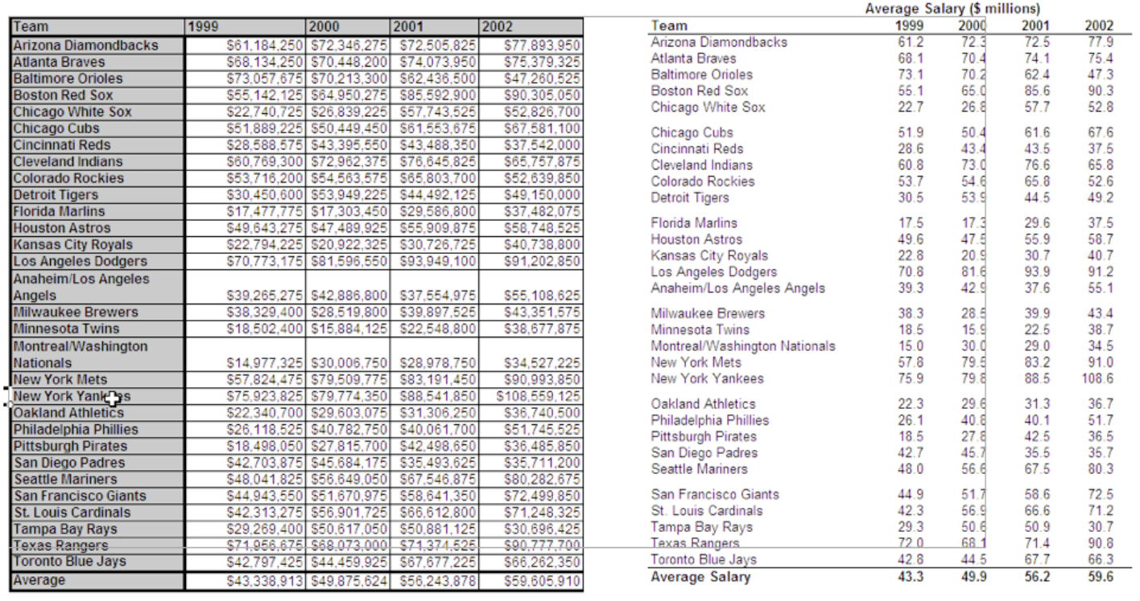

1. **Evaluating your reports**

Once you have designed your dashboard, use these questions as a checklist to make sure if all the elements of your design are working well together

1. What questions are you trying to answer?

* Does this visualization answer all of your questions?
* Is the purpose of the visualization clearly explained in its title or surrounding text?
* Can you understand the visualization in 30 seconds or less, without additional information?
* Does your visualization include a title? Is that simple, informative?

1. Do you have the right chart type for your analysis?

* What types of analysis are you performing?
* Have you selected the most suitable chart types(s) for your types of analysis?
* Have you considered alternative chart types that could work better than the ones you have chosen?

1. Are your charts effective?

* Are your most important data shown on the X- and Y-axes and you less important data encoded in color or shape attributes?
* Are your charts oriented intuitively – do they cater to the way your users read and perceive data?
* Have you limited the number of measures or dimensions in a single chart so that your users can see your data?
* Have you limited your usage of colors and shapes so that users can distinguish them and see patterns?

## **Report guidelines**

1. **Best Practices – Dos and Don’ts**
   * + 1. Trends
          1. While depicting trends over a period of time, try to stick to a specific duration (say 6 months).
       2. Legends
2. Make sure that the labels in the legends are short, so they are completely visible when included on the charts.
   * + - 1. Try to have a maximum of 4-5 values for legend values. Consider grouping some of the categories, wherever possible.
         2. If a legend applies to all of your views, place it together with all of your charts. If a legend applies to one or a few more views, place it as close to that chart(s) as possible.
       1. Table columns
3. Ensure that the column names displayed on the report are meaningful and convey the business value.
4. Avoid using the database column names as is, on the report.
5. Make sure that the column names are completely visible.
   * + 1. Data Format
6. All percentage values be rounded to 2 decimal points, round off the other values to whole numbers.
7. When displaying dates, follow a specific pattern (e.g. mmm-yy).
   * + 1. Titles
8. Titles on Dashboards: On dashboards, there is a provision to mention two titles. Try to rename the titles so the meaning can be conveyed in a single title to avoid confusion.
9. Chart Titles: Give meaningful names to the charts so the users can easily understand the essence of the visuals.
10. Be sure to add titles to every chart on the report.
    * + 1. Tabs on Reports
11. Avoid names like “Page 1”, “Page 2” etc.
12. Add meaningful names to different tabs on all the reports, so the user knows what to expect from the data displayed on that respective tab.
    * + 1. Design
13. Avoid having a horizontal or vertical scroll bar on a dashboard and/or report.
14. Avoid having empty spaces at the end of the report and/or on the sides of the report. Consider re-sizing the charts.
15. Try to stay consistent with displaying x/y axis and/or data labels for charts.
16. Sort the data in the charts when increasing/decreasing trend matters.

# **References**

1. <http://www.perceptualedge.com/articles/visual_business_intelligence/rules_for_using_color.pdf>
2. <https://ideas.powerbi.com/forums/265200-power-bi-ideas/suggestions/6518993-set-colors-and-conditional-formatting-in-visuals>
3. <https://powerbi.microsoft.com/en-us/documentation/powerbi-service-tutorial-customize-x-axis-and-y-axis-properties/>
4. <https://flowingdata.com/2009/11/25/9-ways-to-visualize-proportions-a-guide/>
5. <http://www.makeuseof.com/tag/8-types-excel-charts-use/>
6. <https://fluidsurveys.com/university/use-different-chart-types/>
7. <http://lifehacker.com/5909501/how-to-choose-the-best-chart-for-your-data>
8. <http://www.kaushik.net/avinash/digital-dashboards-strategic-tactical-best-practices-tips-examples/>
9. <https://www.geckoboard.com/blog/building-great-dashboards-6-golden-rules-to-successful-dashboard-design/#.VqfxbE1IjDA>
10. <http://www.cpoc.org/assets/Data/guide_to_dashboard_design1.pdf>
11. <https://developers.google.com/chart/interactive/docs/gallery/piechart?hl=en>
12. <http://www.highcharts.com/demo/area-basic>
13. <http://www.tableau.com/sites/default/files/media/whitepaper_visual-analysis-guidebook_0.pdf>
14. <https://www.perceptualedge.com/articles/Whitepapers/Dashboard_Design.pdf>
15. <https://www.microstrategy.com/Strategy/media/downloads/training-events/microstrategy-world/2014-barcelona/MSTRWorldEU2014_T1_S3_Best_Practices_in_Data_Visualizations.pdf?ext=.pdf>
16. https://medium.com/user-experience-3/the-gutenberg-diagram-in-web-design-e5347c172627#.lqlu16yp3

# **APPENDIX**



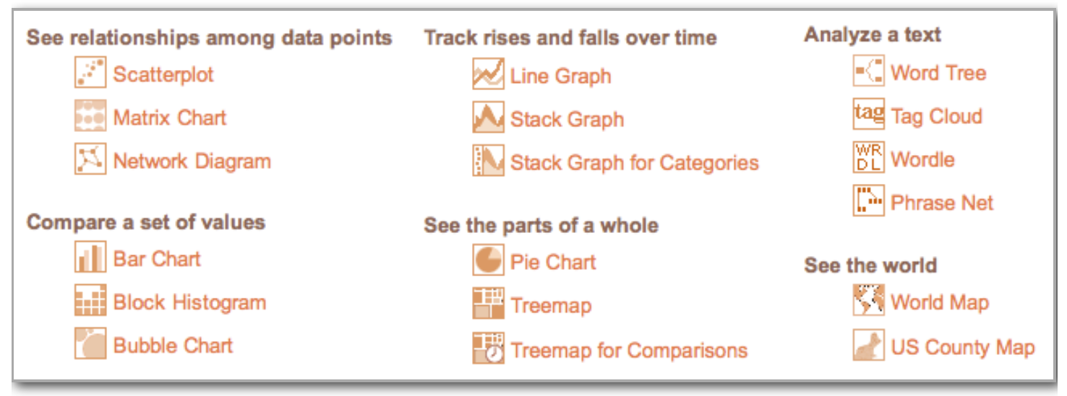

Best practices from other websites

* Include a small description below the main title to give an overview of what the report is about
* Include buttons/tabs on the report to toggle between different years or different options
* Instead of having airline names, we can have airline logos (if they are only few to list)